Supply Chain Network
Network Design & Configuration Documentation
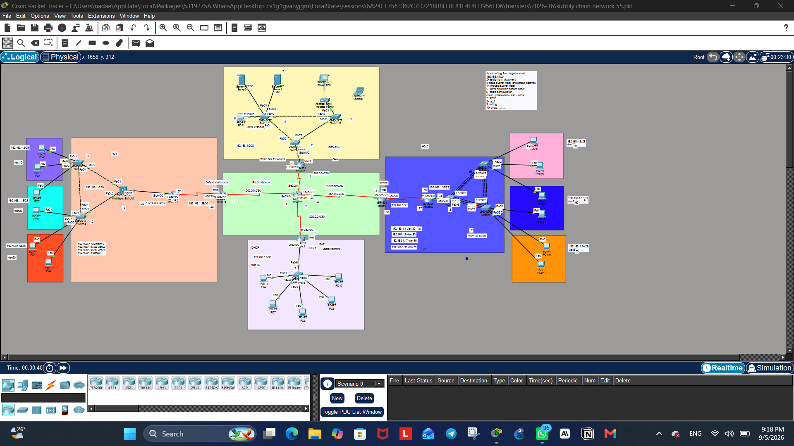
Figure 1: Complete network topology

Prepared by: Nada Elmitwalli
Supervisor: Saher Waleed

Introduction

Project Overview
This project focuses on designing and implementing a secure enterprise network infrastructure that connects multiple company branches through a centralized public network. The primary objective is to enforce strict network segmentation for security purposes, ensuring that devices within one company's network cannot directly communicate with devices in another company's network.
Instead, all inter-branch communication is routed exclusively through dedicated servers, which are made accessible via static public IP addresses. This design enforces a controlled communication model in which any company wishing to exchange data or access shared resources must do so through the server infrastructure, rather than establishing direct host-to-host connections across branches.
This architecture reflects common real-world security practices, where sensitive internal networks are isolated from one another while still allowing controlled, monitored access to shared public-facing services — minimizing the attack surface and preventing unauthorized lateral movement between separate organizational networks.
This level of isolation and controlled access was achieved through a combination of Network Address Translation (NAT), Port Address Translation (PAT), and carefully scoped routing configurations. Static NAT was used to expose the servers with fixed public IP addresses, while PAT was applied on each branch's edge router to allow multiple internal devices to share a single public IP when accessing the servers. Routing was deliberately restricted using a combination of static and dynamic (OSPF) routes, ensuring that each branch could only reach the server network and not other branch networks directly — reinforcing the project's core security objective.

Project Objectives
1. Design a hierarchical, subnetted IP addressing scheme for all company branches.
2. Segment each branch's internal network using VLANs for improved traffic management and security.
3. Implement EtherChannel to provide redundancy and increased bandwidth on critical switch links.
4. Enforce inter-branch isolation, allowing communication only through designated public-facing servers.
5. Configure NAT/PAT to translate private addresses for both server access and general internet-style connectivity.
6. Establish routing using a hybrid static and OSPF approach, matching the security requirements of each network segment.
7. Secure all network devices with password protection, SSH, and Telnet access controls.
8. Testing & Verification.
9. Conclusion.

Section 1: IP Addressing & Subnetting
The IP addressing scheme for this project was designed using a "large to small" subnetting approach, allocating larger address blocks to networks with more hosts and progressively smaller blocks to point-to-point links between routers. This method ensured efficient use of the available address space while keeping each branch's network logically separated and easy to manage.

Public Backbone (Core Network Links)
Link | Network | Router A | Router B
Router4 (HQ1) — Router6 (Core) | 200.0.0.0/30 | Router6 | Router4
Router6 (Core) — Router5 (HQ2) | 201.0.0.0/30 | Router6 | Router5
Router6 (Core) — Router1 (Users Network) | 202.0.0.0/30 | Router6 | Router1
Router6 (Core) — Router0 (Servers) | 203.0.0.0/30 | Router6 | Router0

HQ1 (Private Addressing — via Router4)
VLAN | Network | Subnet Mask | Gateway
VLAN 40 (Management/Native) | 192.168.1.0/29 | 255.255.255.248 | 192.168.1.1
VLAN 10 | 192.168.1.8/29 | 255.255.255.248 | 192.168.1.9
VLAN 20 | 192.168.1.16/29 | 255.255.255.248 | 192.168.1.17
VLAN 30 | 192.168.1.24/29 | 255.255.255.248 | 192.168.1.25
MLS – Router3 Link | 192.168.1.32/30 | 255.255.255.252 | .33 (MLS) / .34 (Router3)
Router3 – Router4 Link | 192.168.1.36/30 | 255.255.255.252 | .37 (Router3) / .38 (Router4)

HQ2 (Private Addressing — via Router5)
VLAN | Network | Subnet Mask | Gateway
VLAN 80 (Management) | 192.168.1.0/29 | 255.255.255.248 | 192.168.1.1
VLAN 50 | 192.168.1.8/29 | 255.255.255.248 | 192.168.1.9
VLAN 60 | 192.168.1.16/29 | 255.255.255.248 | 192.168.1.17
VLAN 70 | 192.168.1.24/29 | 255.255.255.248 | 192.168.1.25
Switch – Router2 Link | 192.168.1.32/30 | 255.255.255.252 | .33 (Switch) / .34 (Router2)
Router2 – Router5 Link | 192.168.1.36/30 | 255.255.255.252 | .37 (Router2) / .38 (Router5)

Users Network (Private Addressing — via Router1)
Segment | Network | Subnet Mask | Gateway
PC / LAN | 192.168.1.0/28 | 255.255.255.240 | 192.168.1.1

Public IP Assignments (Static NAT for Servers)
Device | Private IP | Public IP
Server0 | 192.168.1.6 | 203.0.0.5
Server1 | 192.168.1.7 | 203.0.0.6

Note: The private IP ranges (192.168.1.0/24) are reused independently across HQ1, HQ2, Users Network, and the Servers network. Since each branch is isolated behind its own NAT/PAT boundary, address reuse does not cause conflicts — only the Public Backbone addresses (200.0.0.0/30 – 203.0.0.0/30) need to remain globally unique across the entire topology.

Section 2: VLAN Configuration
VLANs were configured on each branch's access switches to logically segment the network based on department or function, improving traffic isolation, broadcast control, and overall network security. Each VLAN was assigned its own subnet, consistent with the addressing scheme defined in the previous section.
The following configuration demonstrates the creation and assignment of VLANs on the switch's command-line interface. Each VLAN was created, named, and then assigned to its corresponding switch ports to segment the network accordingly.
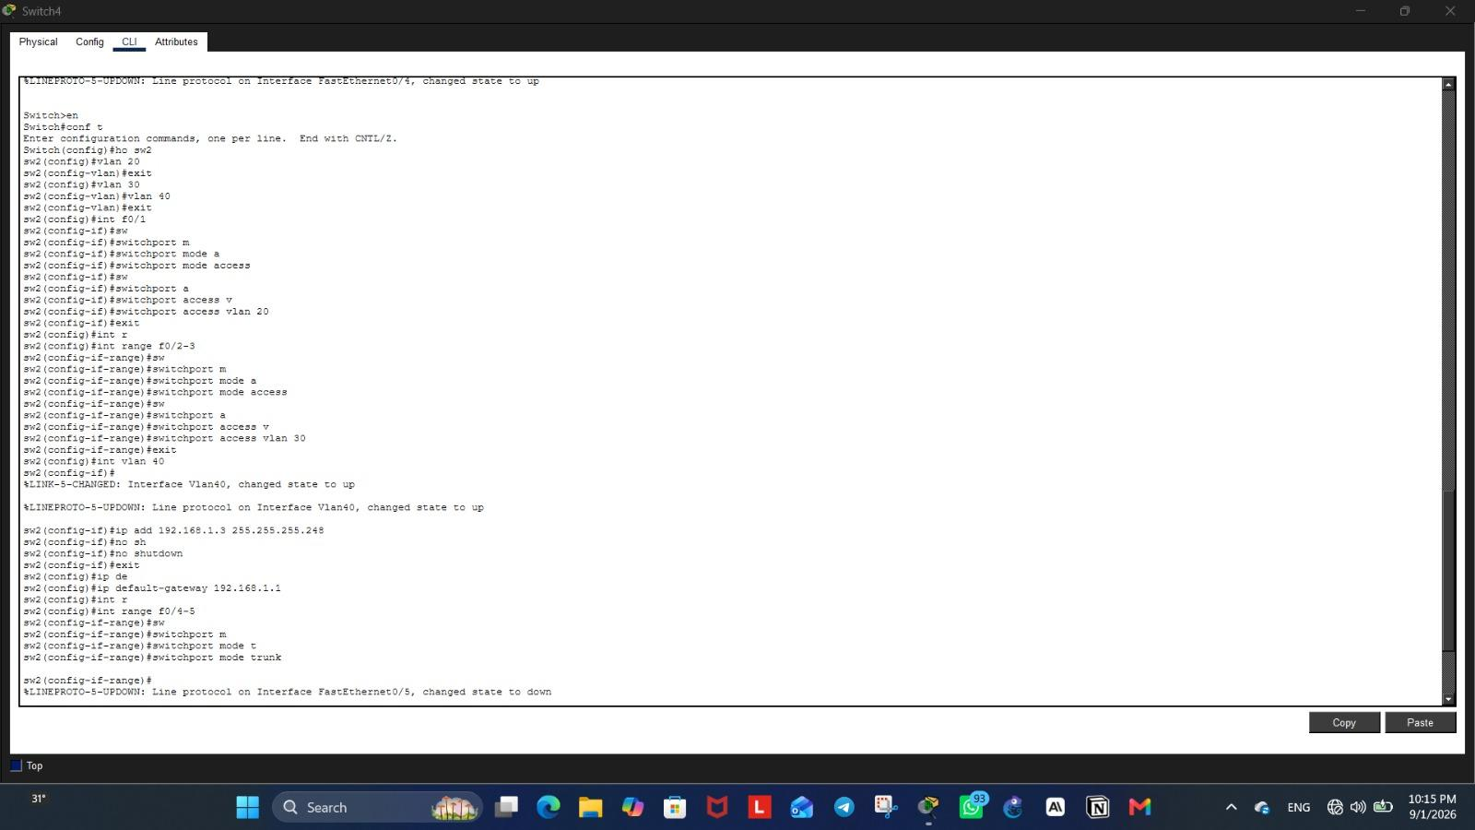
Figure 2: VLAN creation and port assignment on Switch4 (HQ1)

Since the Multilayer Switch is responsible for inter-VLAN routing within HQ1, VLAN interfaces (SVIs) were configured on it to assign each VLAN its own gateway address. The following configuration shows these VLAN interfaces being created and activated.
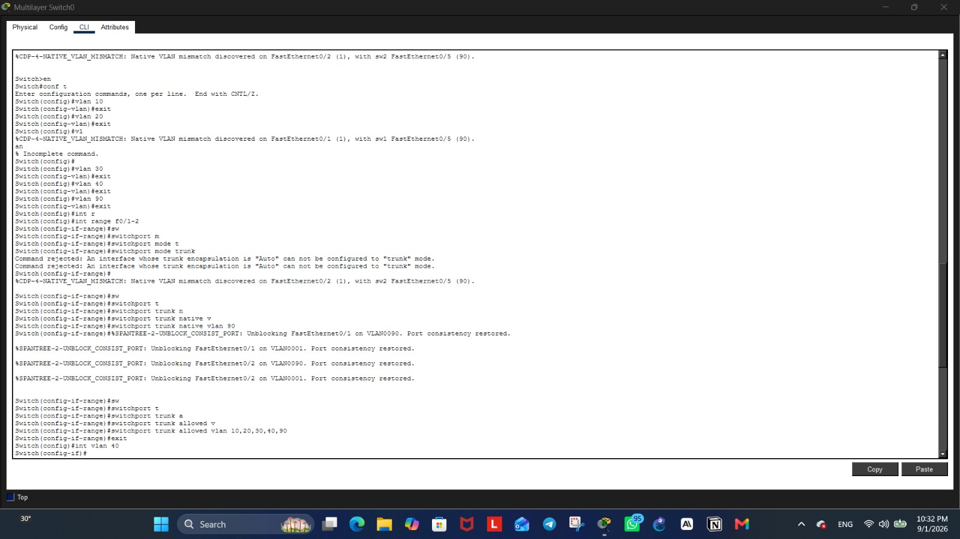
Figure 3: VLAN interface (SVI) configuration on the Multilayer Switch (HQ1)

The main switch shown below belongs to HQ2, the network located on the right side of the topology, acting as the central distribution point that connects the access switches to the edge router while carrying all VLAN traffic across trunk links. The following configuration shows the VLAN and trunk setup on this switch, ensuring proper traffic segmentation across HQ2's connected branches.
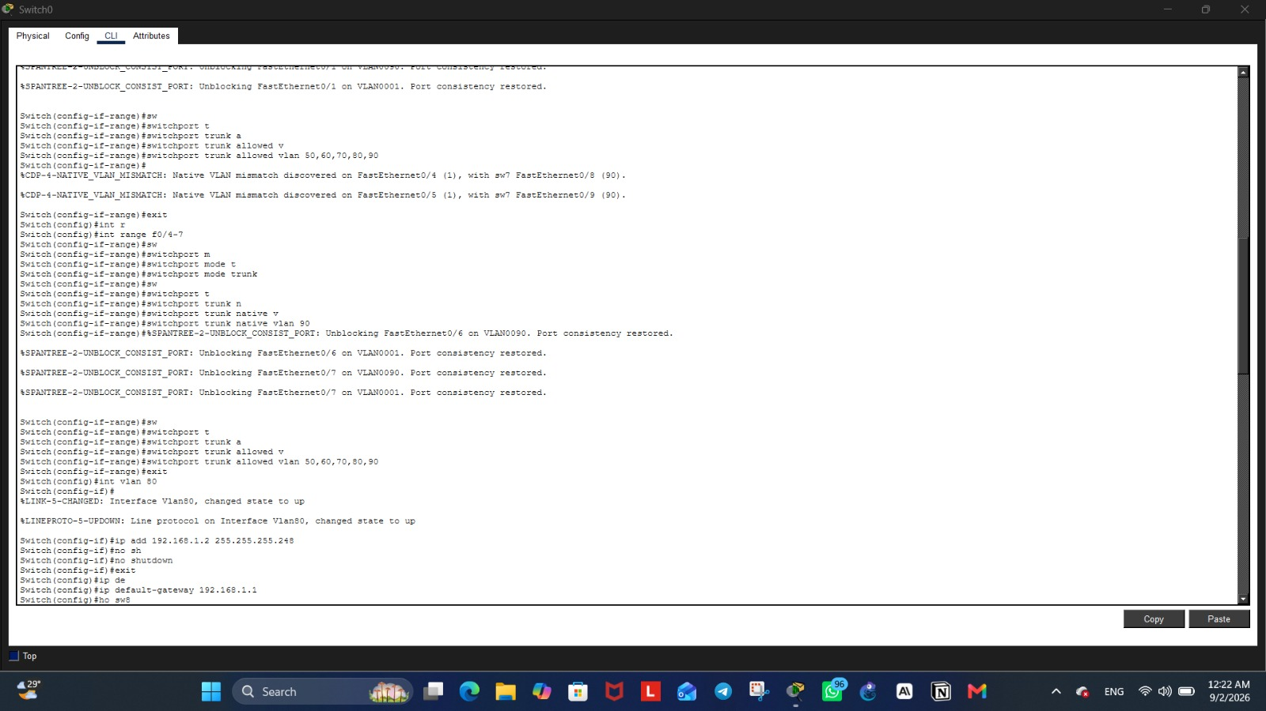
Figure 4: VLAN and trunk configuration on the main switch of HQ2

Section 3: EtherChannel
EtherChannel was implemented on the switches within HQ2 (the network on the right side of the topology) to bundle multiple physical links into a single logical connection. This provides increased bandwidth between the distribution and access switches while adding link redundancy, ensuring that traffic continues to flow even if one of the bundled physical links fails.
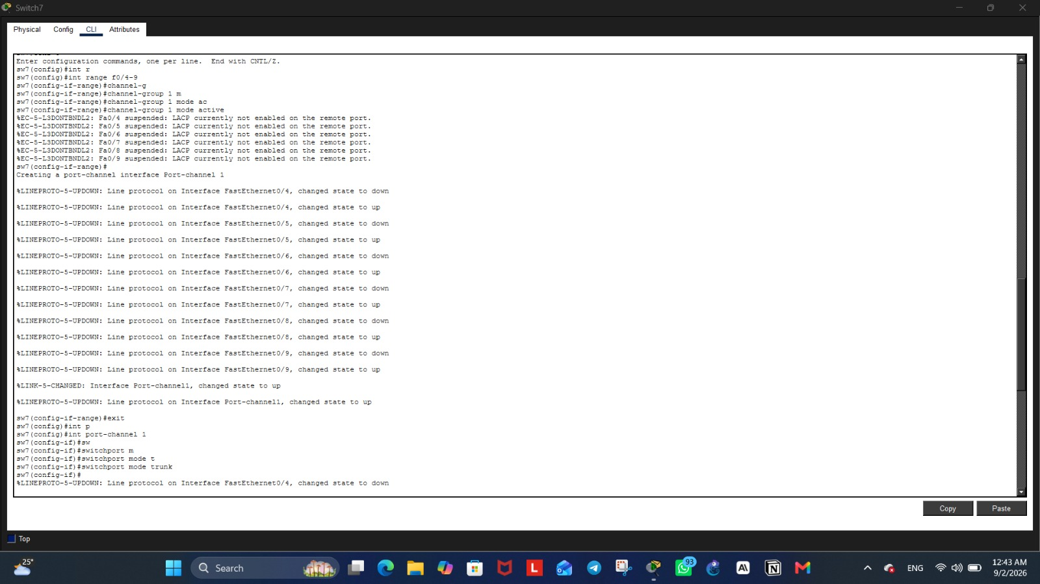
Figure 5: EtherChannel (LACP) configuration on Switch7 (HQ2)

Section 4: Enforcing Inter-Branch Isolation
To meet the project's core security requirement, the network was designed so that no branch could communicate directly with another branch. This isolation is not enforced by a single command, but rather results from the combined effect of the addressing, NAT, and routing decisions made throughout the design: each branch's private network is only known locally, and no direct routes exist between one branch's internal subnet and another's.
As a result, devices in different branches can only reach shared resources — the servers — through their branch's NAT/PAT gateway, using the servers' public IP addresses. Since each branch's internal addressing is never advertised beyond its own edge router, direct host-to-host communication between branches is inherently impossible, regardless of any address overlap between branches.

Section 5: NAT Configuration
Network Address Translation (NAT) was used throughout the project to control how internal devices communicate with the outside network, with two different NAT types applied depending on the purpose of each network segment.

5.1 Static NAT
Static NAT was configured on the router connecting the servers network (the network at the top of the topology) to the public backbone. Since the servers need to be permanently reachable from any branch using a fixed address, each server's private IP was mapped one-to-one to a dedicated public IP address. This ensures that the server's public address never changes, allowing other branches to reliably reach it at all times.
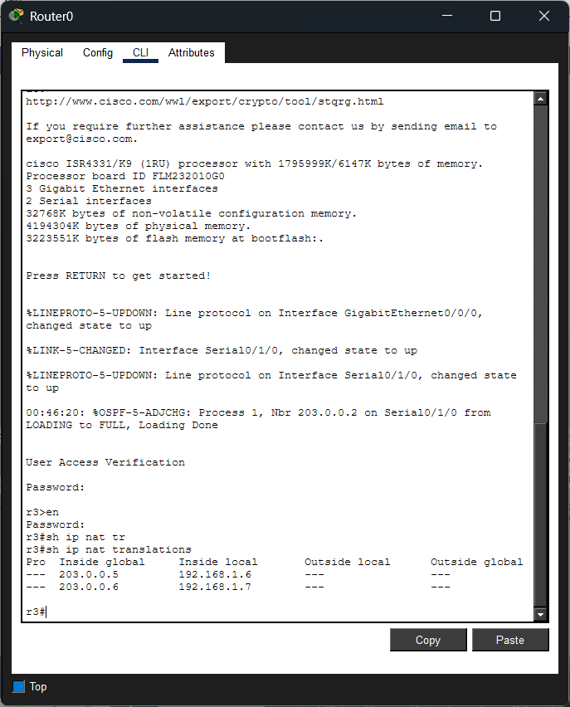
Figure 6: Static NAT translation table on Router0 (Servers network)

5.2 PAT (Port Address Translation)
PAT was configured on the edge routers of the remaining three networks — the network at the bottom (Users Network), the network on the right (HQ2), and the network on the left (HQ1). Since these networks contain multiple internal devices that only need to initiate outbound connections toward the servers, rather than being reached from outside, PAT was the appropriate choice.
Using PAT, all devices within each branch share a single public IP address — the edge router's outbound interface address — while being distinguished from one another using unique port numbers. This allows many internal devices to communicate with the servers simultaneously without requiring a separate public IP for each device, conserving public address space while still meeting the branch's connectivity needs.
! Applied on Router4 (HQ1), Router5 (HQ2), and Router1 (Users Network)
access-list 1 permit 192.168.1.0 0.0.0.31

Section 6: Routing Configuration
Routing in this project is based entirely on OSPF. Every router — the Multilayer Switch, the internal routers, the edge (PAT) routers, and the central router — runs OSPF and advertises its directly connected networks into Area 0. This gives every device full dynamic reachability without manually maintained static routes, and lets the network automatically adapt if a link or a router's addressing changes.

6.1 OSPF Configuration (All Routers)
OSPF was enabled on the Multilayer Switch, the internal routers of each branch (Router3 in HQ1, Router2 in HQ2), the edge routers that perform PAT (Router4, Router5, Router1), and the central router (Router6). Each device advertises every network it is directly connected to — its VLAN interfaces, its link to the next device in the chain, and the backbone link where applicable — so that reachability across the whole topology is learned dynamically rather than configured by hand.
router ospf 1
log-adjacency-changes
network 192.168.1.0 0.0.0.7 area 0
network 192.168.1.8 0.0.0.7 area 0
network 192.168.1.16 0.0.0.7 area 0
network 192.168.1.24 0.0.0.7 area 0
network 192.168.1.32 0.0.0.3 area 0
network 192.168.1.36 0.0.0.3 area 0

6.2 Default Route Propagation via OSPF
Rather than configuring a static default route on each stub device, the central router (Router6) and the servers' edge router (Router0) originate a default route into OSPF using the default-information originate command. This single default route propagates automatically to every OSPF-enabled router in the topology — including the Multilayer Switch and the internal routers — so that any traffic destined outside the explicitly advertised networks is still forwarded correctly, without a manually maintained static entry on every device.
This also means that if a branch's internal addressing or topology changes, every router simply relearns its routes through OSPF, with nothing to update by hand.
router ospf 1
network 200.0.0.0 0.0.0.3 area 0
network 201.0.0.0 0.0.0.3 area 0
network 202.0.0.0 0.0.0.3 area 0
network 203.0.0.0 0.0.0.3 area 0
default-information originate

Section 7: Security Configuration
To protect the network devices from unauthorized access, password protection along with SSH and Telnet access controls were configured on all network devices, including routers and switches.
Console and privileged EXEC passwords were set to restrict local access to each device, while SSH was configured to provide a secure, encrypted method for remote management, replacing the less secure Telnet protocol for sensitive configuration tasks. Telnet access was also configured where required, with appropriate authentication in place to control who could establish a remote session.
These measures ensure that only authorized personnel can access and modify the network's configuration, reducing the risk of unauthorized changes or security breaches.
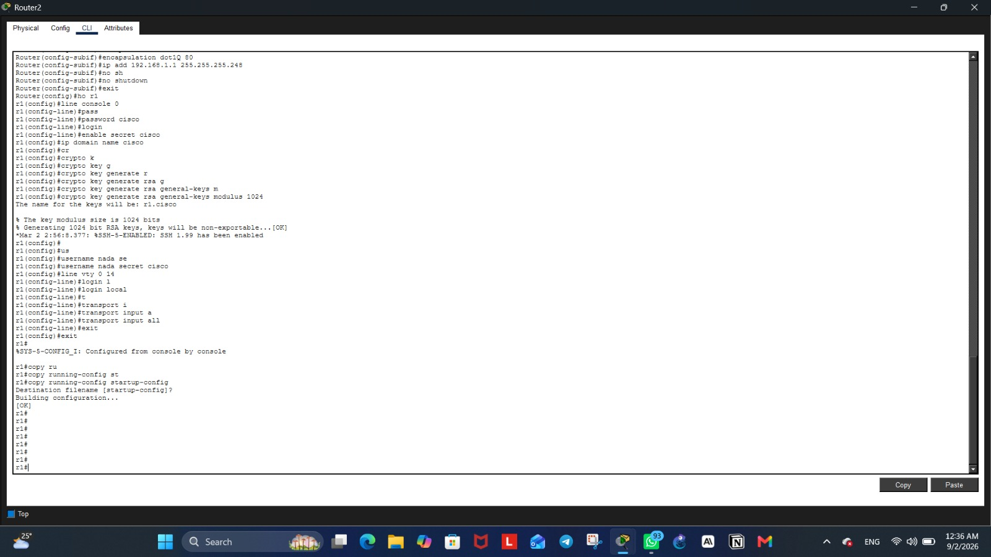
Figure 7: Password, SSH, and Telnet configuration on Router2

Section 8: Testing & Verification
To confirm that the network was functioning as intended, a final connectivity test was performed by pinging the server's public IP address from a device in one of the branches. The successful response, shown below, confirms that the NAT/PAT translation, OSPF and static routing, and overall network configuration are all working correctly together — allowing devices across the isolated branches to reach the shared servers exactly as designed.
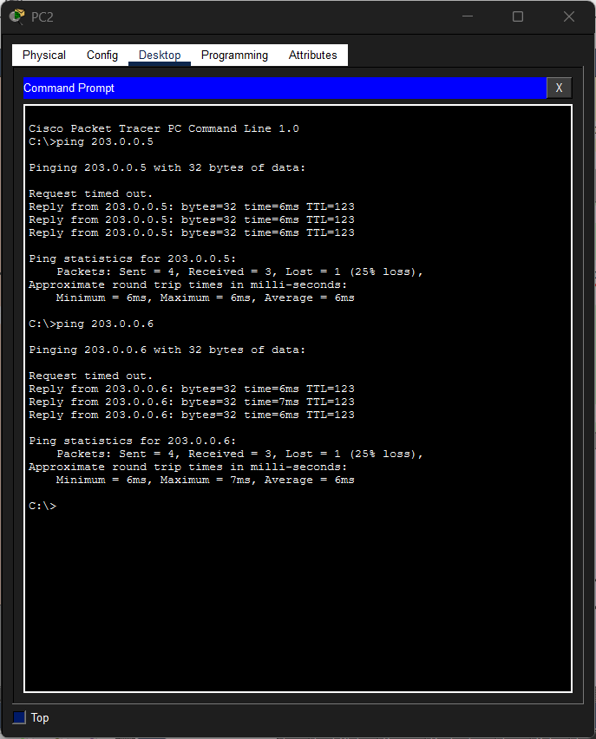
Figure 8: Successful ping test from PC2 to the servers' public IP addresses

Section 9: Troubleshooting Notes
During testing, one VLAN (VLAN10 in HQ1) was found to fail to reach the servers' public IP addresses, while all other VLANs and branches worked correctly. This section documents the troubleshooting process and root cause, as it illustrates a subtle but important routing issue caused by address range reuse across branches.

Symptom
A traceroute from a VLAN10 host toward the servers' public IP (203.0.0.5) reached the local gateway and the internal router (Router3) successfully, but timed out at every hop beyond that point. Other VLANs in the same branch (VLAN20, VLAN30) reached the servers without issue.

Investigation
1. Verified the PAT access-list on Router4 — VLAN10's subnet (192.168.1.8/29) was correctly permitted, and the match counter increased with each test, confirming packets were reaching the NAT process.
2. Ruled out an incorrectly configured NAT pool that had briefly been introduced during testing (it was removed and replaced with the correct interface-based PAT overload).
3. Checked for access-lists applied directly to the interfaces between Router3 and Router4 — none were found in either direction.
4. Performed a step-by-step ping test (gateway → Router3 → Router4) and found that traffic reached Router3 successfully but failed specifically when reaching Router4's interface (192.168.1.38).
5. Examined Router4's routing table with "show ip route 192.168.1.9" and discovered the route was being learned via OSPF as 192.168.1.0/28, pointing toward Router6 — the wrong direction — instead of via the correct static route (192.168.1.0/24 via Router3).

Root Cause
Router1 (Users Network) was advertising its local subnet (192.168.1.0/28) into OSPF. Because the private address ranges are intentionally reused across branches, this /28 network happened to numerically overlap with part of HQ1's VLAN10 range (192.168.1.8/29 falls within 192.168.1.0–15). Since routers always prefer the most specific matching route regardless of whether it is static or dynamic, Router4 selected the OSPF-learned /28 route over the correct, broader static route — sending VLAN10's return traffic toward the core network instead of back to Router3. VLAN20 and VLAN30 were unaffected because their address ranges fall outside the overlapping /28 block.

Resolution
The stray network statement was removed from Router1's OSPF configuration so that its internal subnet is no longer advertised beyond its own edge router:
router ospf 1
no network 192.168.1.0 0.0.0.15 area 0
While reviewing Router1 for this issue, two additional inconsistencies were found and corrected for clarity and reliability:
1. Its default static route pointed to 200.0.0.6, an address outside any network directly connected to Router1, making the route unreachable. It was corrected to point to Router6's actual interface address (202.0.0.2):
no ip route 0.0.0.0 0.0.0.0 200.0.0.6
ip route 0.0.0.0 0.0.0.0 202.0.0.2
2. Its OSPF configuration included a network statement (200.0.0.4 0.0.0.3 area 0) that did not correspond to any interface on this router — leftover from an earlier configuration step — and the PAT access-list contained two redundant, overlapping entries. Both were removed:
router ospf 1
no network 200.0.0.4 0.0.0.3 area 0
!
no access-list 1 permit 192.168.1.0 0.0.0.3
no access-list 1 permit 192.168.1.0 0.0.0.7
After these changes, Router4 correctly resolved traffic to VLAN10 via the static route through Router3, and connectivity to the servers' public IPs was confirmed across all branches and VLANs.
Key takeaway: reusing the same private address ranges across independently NAT'd branches is safe only as long as those ranges are never advertised into a shared dynamic routing protocol. Stub/internal networks should remain strictly static, with only backbone links participating in OSPF.
Note: the static default route and static management route mentioned above reflect the configuration in place at the time this issue was diagnosed. The routing design was subsequently migrated to the fully OSPF-based approach described in Section 6, under which every router — including Router1 and Router4 — now learns its default route dynamically via OSPF instead of a manually configured static route.

Conclusion
This project successfully demonstrates the design and implementation of a secure, segmented enterprise network connecting multiple company branches through a controlled, server-mediated communication model. Through careful subnetting, VLAN segmentation, EtherChannel redundancy, NAT/PAT translation, and a fully OSPF-based dynamic routing design, the network achieves its core objective: enforcing strict isolation between branches while still enabling reliable, secure access to shared resources.
Beyond meeting the technical requirements, this project provided valuable hands-on experience in troubleshooting real-world networking challenges — from resolving EtherChannel mismatches and OSPF adjacency issues to correcting NAT misconfigurations — reinforcing both the theoretical concepts and practical skills required for enterprise network design and administration.

